**<ONLINE JOB PORTAL>**

A PROJECT REPORT

Under the guidance of

**Mr. A. L. SENTHIL KUMAR**

Submitted by

**Miss. GAURI NAMDEO RAUT**

**Roll No.: 1405000198**

In partial fulfillment of the requirement for the award of the degree

Of

Master of Computer Applications

Department of Information Technology



May – 2017



BONAFIDE CERTIFICATE

Certified that this project report titled “ONLINE JOB PORTAL” is the bona-fide work of “Miss. GAURI NAMDEO RAUT with REG.NO. 1405000198” who carried out the project work under my supervision.

SIGNATURE

GUIDE: **Mr. A. L. SENTHIL KUMAR**

**ABSTRACT**

In this competitive era, the education among the people is so increasing that the jobs for them are now decreasing. This project is about the recruitment process which is done online. The recruitment process here is handled by the system. This project will allow the person to apply for a job in the company for the interested vacancy which would be available at the company. The person will be having the account after registration and will be then called the applied user. If he would be qualified, he would be interacting with the system for the updates. The project is created for fulfilling the requests of the company managers so that the recruitment module can be placed in the company’s website and the users who visit the website can view the vacancies in the company and will be able to apply directly from remote place even. The vacancies will be posted by the administrator on the basis of needs of the manpower in the company.

**Table of Contents**

|  |  |  |
| --- | --- | --- |
| **CHAPTER NO.** | **TITLE** | **PAGE No.** |
|  | List of Tables | 5 |
| 1 | Introduction | 9-15 |
|  | 1.1. Organizational overview | 9 |
|  | 1.2. Current System | 10 |
|  | 1.3. Limitations of the current system | 10 |
|  | 1.4. Scope of project | 11 |
|  | 1.5. Proposed System and its advantages | 12 |
|  | 1.6. Feasibility study | 13 |
|  | 1.7. Process Model | 15 |
| 2 | Requirement Specification | 20-40 |
|  | 2.1. Event Table | 20 |
|  | 2.2. Use Case | 23 |
|  | 2.3. ER Diagram | 29 |
|  | 2.4. Activity Diagrams | 30 |
|  | 2.5. Class Diagram | 35 |
|  | 2.6. System Sequence Diagram | 36 |
|  | 2.7. Sequence Diagram | 40 |
| 3 | System Design | 42-49 |
|  | 3.1. Converting ERD to Class | 42 |
|  | 3.2. Data Dictionary | 43 |
|  | 3.3. Package Diagram | 47 |
|  | 3.4. Deployment Diagram | 48 |
|  | 3.5. Menu Tree | 49 |
| 4 | Implementation | 50-55 |
|  | 4.1 Software Testing | 50 |
|  | 4.2. Validations | 54 |
|  | 4.3. Test Cases/Test Data | 55 |
| 5 | Results | 56-60 |
|  | 5.1. Screen Layouts: | 56 |
| 6 | Limitations and Future Application of the Project | 61-65 |
|  | 6.1. Future Enhancement | 61 |
|  | 6.2. Implementation & Maintenance | 62 |
| 7 | Conclusion | 66 |
| 8 | Bibliography | 67 |

**List of Tables**

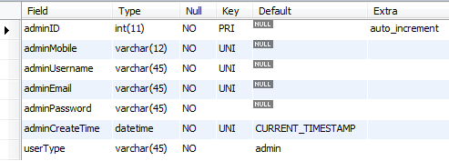Admin Table

Registration Table

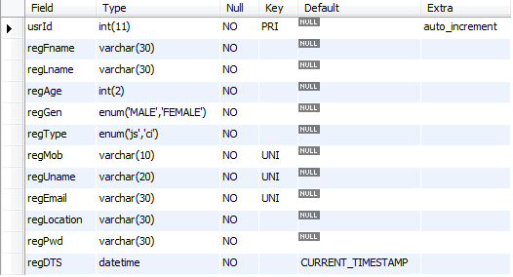

Jobseeker Info table

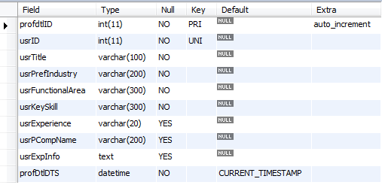

Companies Info table

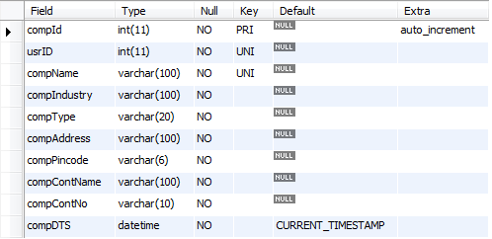

Profile Image, C.V and Company URL table

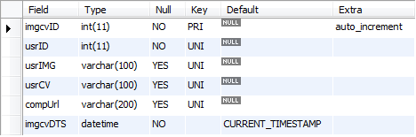

Job Posting by company table

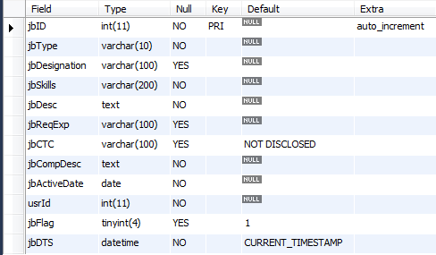

Job Application table

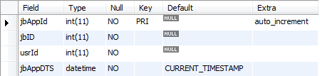

Feedback table

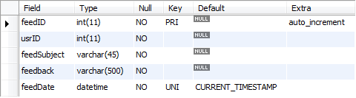

**Chapter 1: Introduction**

* 1. **Organizational overview:**

**Online Job Portal** is developed for creating an interactive job vacancy for candidates.

This web application is to be conceived in its current form as a dynamic site-requiring constant updates both from the seekers as well as the companies.

On the whole the objective of the project is to enable jobseekers to place their resumes and companies to publish their vacancies.

It enables jobseekers to post their resume, search for jobs, view personal job listings.

It will provide various companies to place their vacancy profile on the site and also have an option to search candidate resumes.

Recruiters view their profile from database and contact if they expect from those jobseekers to be suitable for particular vacancy.

* 1. **Current System:**

Before creating this website, all jobseekers to send their resumes or information through postal mails or they use person to person contacts with each other.

At present, there is a job-crisis and it’s very hard to find jobs for employees. Even if the employees are having good talent, they suffer in finding the right job. Also that is not easy for the recruiters to recruit perfect employees what they exactly want. It will take long time to send their requirements through this type of communications.

Here there May error occurs in the process, then administration faces the problems to collect all the information from clients and consultants to analyze the requirement in the corresponding Clients. Administration has to send requirements information to different consultants and jobseekers.

Some employees are employed, but not at the place where they really should be.

* 1. **Limitations of the current system:.**

As mention, in the existing system the procedure is quite simple but it requires much feasible and speed which a manual system can’t provide. The major drawbacks are as follows:

* The process is very slow of searching Jobs manually.
* Too much time consuming.
  1. **Scope of project:**

We have developed the job-portal. This portal can handle data of Recruits (Several Companies) who are looking for suitable candidates for their vacancies.

This portal will be most useful for Consultants for searching of matching job with jobseekers etc.

The classic Functionality of this Application focuses on data storage. However, the means to retrieve and analyze data, to extract, transform and load data, and to manage the data dictionary.

An administrator is provided through which can enter Recruiter’s record /type of jobs/jobseeker’s description. A registration form is provided through which user can enter details of company like location of company/type of job/status of job/Qualification of jobseekers. This data once entered can be edited/deleted as required when there will be vast entries of data user can scroll the data.

There are sections provided for Recruiter Requirement/Resource**.**

This project is aimed at developing a web-based and central **ONLINE JOB PORTAL** for the HR Group for a company. Some features of this system will be creating vacancies, storing Applicants data, Interview process initiation, Scheduling Interviews, Storing Interview results for the applicant and finally Hiring of the applicant. Reports may be required to be generated for the use of HR group.

This system automates the manual recruitment process. We believe that once the organization chooses to use this system, it will eventually recognize the value and necessity of this system and understand the problems involved in the manual process.

This document provides details about the entire software requirements specification for the online job portal. The project Online Job portal is aimed at developing a web-based and central Recruitment Process System for the HR Group of a company.

* 1. **Proposed System and its advantages:**
* Here all job seekers send their resumes or information through our site.
* It does not consume much of time.
* It is very easier to modify if any error occurs in the process.
* It is also very easier to administrator to collect information from clients and consultants.
* **Users of the system:**
* The users of this system are administrator, clients, job provider and jobseekers.
* This system is designed such a way that the users can easily interact with the system with minimum knowledge to browser the net and company rules.
* **Module Description:**

The proposed system is developed by using four modules:

1. Job Seeker.

2. Job Provider.

3. Administrator.

* 1. **Feasibility study:**

A Feasibility study is the study of the positive possibilities of the project. The study is always done as a part of finding the fact finding techniques and revised when the system is finally being proposed.

* The Project Feasibility is concerned with expected benefits.
* An Important outcome of the preliminary investigation is the destination that the proposed system is feasible.
* There are three aspects in the feasibility study portion of the preliminary investigation.
  + Economic Feasibility
  + Operational Feasibility
  + Technical Feasibility
* **ECONOMIC FEASIBILITY:**

It is considered mainly of two tests:

*a) Anticipated Value of benefit is greater than cost of development*

*b) Does the organization have adequate cash flow to fund the project?*

A determination to economic feasibility of the project requires the low cost/ benefit analysis. The cost/benefit analysis compares the cost and benefit to see whether the investment in development of a new system will be more beneficial than costly. Automation leads to reduction of manpower and processing time. They purchase software with minimum rate.

Thus the system is said to be economically feasible.

* **OPERATIONAL FEASIBILITY:**

Proposed projects are beneficial only if they can be turned into information systems that will meet the organizations operating requirements.

Simply stated, this test of feasibility asks if the system will work when it is developed and installed.

Are there major barriers to implementation?

Here are questions that will help test the operational feasibility of a project.

Is there sufficient support for the project from management from users?

If the current system is well liked and used to the extent that persons will not be able to see reasons for change, there may be resistance.

Are the current business methods acceptable to the user? If they are not, Users may welcome a change that will bring about a more operational and useful systems.

Have the user been involved in the planning and development of the project? Early involvement reduces the chances of resistance to the system and in general and increases the likelihood of successful project.

Since the proposed system was to help reduce the hardships encountered. In the existing manual system, the new system was considered to be operational feasible.

* **TECHNICAL FEASIBILITY:**

Technical Feasibility assesses the details of how you will deliver product or service. It is a study of an excellent for troubleshooting and long term planning.

Hardware Requirements:

|  |  |
| --- | --- |
| Content | Description |
| HDD | 10 GB Min  40 GB Recommended |
| RAM | 512 GB Min  1 GB Recommended |

Software Requirements:

|  |  |
| --- | --- |
| Content | Description |
| OS | Windows XP with SP2 or Windows Vista or higher |
| Database | MYSQL Server |
| Technologies | C# |
| IDE | Visual Studio |

##### Process Model:

The Process Model means the design, testing and implementation of the project. This is also known as Classic Life Cycle Model or Linear Sequential Model or Waterfall Model. It includes various phases and activities. The activities are as listed below in the following manner:

##### System Analysis and Design:

Easy track is based on waterfall model of software engineering. In “WATERFALL MODEL”, the process software development is divided into separate process phases.

All these phases are cascaded to each other so that second phase is starts as and when defined set of goals are achieved for the first phase and it is signed off. So the name is suggested as “WATERFALL MODEL”.

General view of a “WATERFALL MODEL” is given below,

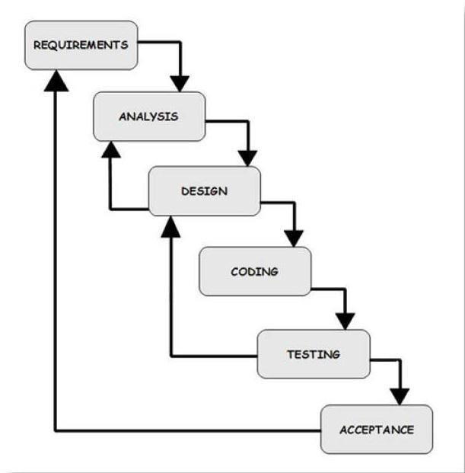

The stages of **“WATERFALL MODEL”** are requirement of the system to develop are captured in this phase. Requirements are the set of functionalities and constraints that the end-user (who will be using this system) accepts from the end-user. The requirements are gathered from the end-user by consultation these requirements are analyzed for their validity and the possibility of incorporating the requirements in the system to develop is also studied. Finally, a requirement specification document is carried which serves the purpose of guidelines for the next phase of the model. It is called as **Software Requirement Specification (SRS)**.

##### System and Software Design:

Before starting to the actual coding of any project, it is highly easy to understand what we are going to create and what it should look like? The requirement specification from first phase is studied in the phase and the system design is prepared. System design helps in specifying hardware and system requirement and also helps in defining overall system architecture. The system design specification serves as input for the next phase of the model.

##### Analysis:

The overall code of software in larger system is identified during system engineering. However it’s necessary to take a harder look at the software’s role to understand the specific requirements that must be achieved to build high quality software. That’s the job of software requirements analysis.

The requirement modeling activity for a system c/s from the analysis modeling methods applied to more conventional computers architectures because analysis modeling avoids specification of implementation detail issues associated with the allocation of software components of client and server are considered as only as transaction made to design.

However, an evolutionary approach to software engineering is applied for c/s system. Implementation decision on over all c/s approach may be made during early analysis and design iterations.

The steps involved in analysis include data; functional and behavioral requirements begin identified by electing information from the customer. Requirements are refined and analyzed to access their clarity, completeness and consistency. A specification incorporating a model of software is created and then validated.

##### Analysis has a set of operational principles which are as follows:

1. The information domain of a problem must be represented and understood.
2. The functions that the software has to perform must be defined.
3. The behavior of the software must be represented.
4. The models that depict information function and behavior must be partitioned in a manner that uncovers detail in layered fashion.
5. The analysis process should move from essential information towards implementation detail.

##### Requirement Analysis:

Requirement analysis is software engineering task that bridges the gap between the system level requirement and software design.

These activities result in the specification of the software operational characteristics indicate the software interface with other systems elements and establish constraints that the software must meet.

##### Implementation and Unit Testing:

On receiving system design document i.e. SRS (Software Requirement Specification) now the work is divided into modules or in units and actual coding of a project is started.

The system is first developed in small programs and then they are integrated in the next phase.

After each unit development it is tested and its functionality is checked, this is referred as unit testing.

Unit testing mainly modified if the models or units meet their specification.

##### Integrated and System Testing:

As specified above the system is divided in units which are developed and tested for their functionalities. These units are integrated into a complete system as a whole behaves as per the specifications. After successfully testing the software, it is delivered to the customer.

##### Operation and Maintenance:

This phase of the **“WATERFALL MODEL”** is virtually never ending phase. Generally, problems with the system developed come up after its practical use starts, so the issues related to the system are solved after development of the system.

Not all the problems come in picture directly but they arise time to time and needs to be solved, hence this process is referred to as maintenance.

The waterfall model development helped us because our team size was small as it was just two members working on this project so it is precise, as compared to vastness and complexity of the project.

It helped us to meet with business deadlines by customers with prototype, thereby enabling partial functionality without inordinate delay.

We delivered our first trial version, the core product at no charge to the organization for a trial period. This helped the customer get feel of the system and more of gave us useful suggestion and feedback that helped us plan what could be implemented in the next version.

The feedback helped us to modify the core product to better the needs of the customer and delivery of additional needs and functionality.

**Gantt chart**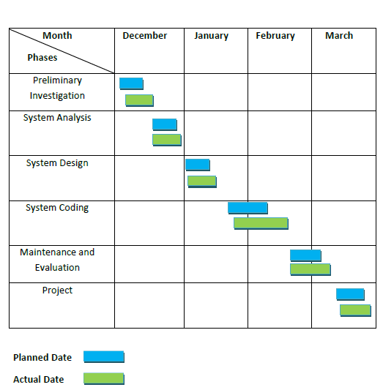

**Chapter 2: Requirement Specification**

**2.1**. **Event Table:**

A UML Event Table is an interaction between user and a system. The user sends an event which is fired by a trigger from source after that interaction is done with the system and response given back to the user.

1. **Trigger** is an occurrence that tells the system that an event has occurred, either the arrival of data needing processing or of a point in time.
2. **Source** is an external agent or actor that supplies data to the system.
3. **Activity** is a behavior that the system performs when an event occurs.
4. **Response** is an output, produced by the system that goes to a destination.
5. **Destination** is an external agent or actor that receives data from the system

|  |  |  |  |  |  |  |
| --- | --- | --- | --- | --- | --- | --- |
| Sr. | Events | Triggers | Source | Use case | Response | Destination |
| 1 | Login | User request for login | User | Enter User Credentials | Logged in/ Incorrect Credentials | User |
| 2 | Register | User request for registration | User | Enter required registration details | New User registered successfully | Database |
| 3 | Forget password | User request for password | Database | Enter required details | Displays password | User |
| 4 | Change Password | User request for changing password | User | Enter old and new password | Password changed successfully | Database |
| 5 | User(applicant) | Create new profile | User(applicant) | Enter profile details | User profile created | Database |
| 6 | User(applicant) | Update applicant details | User(applicant) | Update required details | Profile updated successfully | Database |
| 7 | User(applicant) | Delete applicant profile | User(applicant) | Deletes profile | Profile deleted successfully | Database |
| 8 | User(applicant) | Uploads resume | User(applicant) | Uploads resume | Resume uploaded successfully | Database |
| 9 | User(applicant) | Views jobs | User(applicant) | Views new job list | Viewed jobs | Database |
| 10 | User(applicant) | save jobs | User(applicant) | Saves job | Saved jobs | Database |
| 11 | User(applicant) | Apply for job | User(applicant) | Applying for jobs | Applied for job | Database |
| 12 | User(applicant) | Cancel Application for job | User(applicant) | Cancelling Application for jobs | Canceled applied jobs | Database |
| 13 | User(Company) | Creates company | User(company) | Enter profile | Company profile | Database |
|  |  | profile |  | details | created successfully |  |
| 14 | User(Company) | Update company details | User(Company) | Update required details | Profile updated successfully | Database |
| 15 | User(Company) | Delete company profile | User(Company) | Deletes profile | Profile deleted successfully | Database |
| 16 | User(Company) | View candidate list | Database | Viewing candidates details | View candidate profiles | User(Company) |
| 17 | User(Company) | Posts new job | User(Company) | Posting new job | Posted job | Database |
| 18 | User(Company) | Update job details | User(Company) | Updates job details | Job details updated | Database |
| 19 | User(Company) | Delete filled job details | User(Company) | Delete vacancy filled job | Deleted no vacancy job | Database |
| 20 | User(Company | View candidate applied for job | Database | Viewing applied candidate | Views candidate applied for job | User(Company) |
| 21 | User(Admin) | Views company list | Database | Views company lists | Company list displays | User(Admin) |
| 22 | User(Admin) | Views candidate list | Database | Views candidate list | Candidate list displays | User(Admin) |
| 23 | User(Admin) | Verify company | User(Admin) | Verifies company listed | Company verified | Database |
| 24 | User(Admin) | Verify candidate | User(Admin) | Verify candidate listed | Candidate verified | Database |
| 25 | User(Admin) | Delete fake company | User(Admin) | Deletes fake company | Company deleted | Database |
| 26 | User(Admin) | Delete fake candidate | User(Admin) | Deletes fake candidate | Candidate deleted | Database |
| 27 | User(Admin) | Deletes old dated job | User(Admin) | Deletes old dated jobs | Deleted old jobs | Database |
| 28 | User(Admin) | Remind not active user | User(Admin) | Reminding inactive users | User reminded | User(candidate) |
| 29 | User(Admin) | Organize event | User(Admin) | Organizing events | Event organized | Database |
| 30 | User(Admin) | Update events | User(Admin) | Updating events | Event updated | Database |

**2.2. Use Case:**

A UML Use Case Diagram is for the interaction of a client (the actor) and a restaurant (the system). In software and system engineering, a use case is a list of steps, typically defining interactions between role (known in UML as a **͞actor͟**)and a system, to achieve a goal. The actor can be a human or an external system.

**System Boundary**

A system boundary defines the scope of what a system will be. A system cannot have infinite functionality. So, it follows that use cases also need to have definitive limits defined. A system boundary of a use case diagram defines the limits of the system. The system boundary is shown as a rectangle spanning all the use cases in the system.

System

Login

Register

Forget password

USER

Change password

Delete Account

System

View Company list

Delete fake company

View candidate list

Delete fake candidate

ADMIN

Remainder to inactive user

Organize events

Update events

Delete old events

Send newsletters

System

Create new profile

Update profile

Delete profile

Upload resume

CANDIDATE

View jobs

Save/Apply jobs

Cancel jobs

Views company details

System

Create profile

Update profile

Delete profile

View candidate list

COMPANY

Post jobs

Update jobs

Delete old jobs

Views applied candidates

System

Create profile

Update profile

Delete profile

View candidate list

COMPANY

Post jobs

Update jobs

Delete old jobs

Views applied candidates

System

Create new profile

Update profile

Delete profile

Upload resume

CANDIDATE

View jobs

Save/Apply jobs

Cancel jobs

Views company details

**2.3. ER Diagram:**

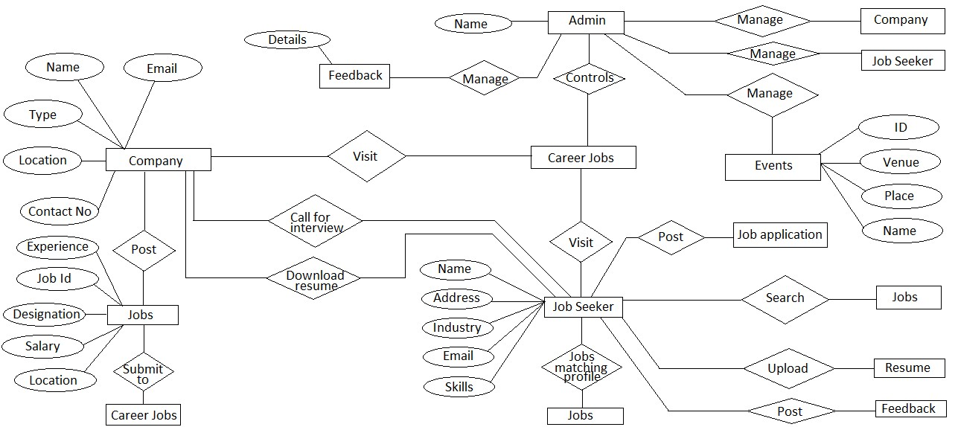

**2.4. Activity Diagrams:**

Activities are a representation of the various operations performed by a class. An activity diagram depicts the flow of control from one activity to another.

Activity diagram can be drawn by identifying the activities performed by the various classes of the system.

1. **Action States:** Action states represent the no interruptible actions of objects. You can draw an action state in Smart Draw using a rectangle with rounded corners.
2. **Action Flow:** Action flow arrows illustrate the relationships among action states.
3. **Object Flow:** Object flow refers to the creation and modification of objects by activities. An object flow arrow from an action to an object means that the action creates or influences the object. An object flow arrow from an object to an action indicates that the action state uses the object.
4. **Initial State:** A filled circle followed by an arrow represents the initial action state.
5. **Final State:** An arrow pointing to a filled circle nested inside another circle represents the final action state.
6. **Branching:** A diamond represents a decision with alternate paths. The outgoing alternates should be labeled with a condition or guard expression. You can also label one of the paths “else”.
7. **Synchronization:** A synchronization bar helps illustrate parallel transitions. Synchronization is also called for king and joining.
8. **Swim lanes:** Swim lanes group related activities into one column. Activity diagrams provide another ability, to clarify which actor performs which activity.

Login Activity

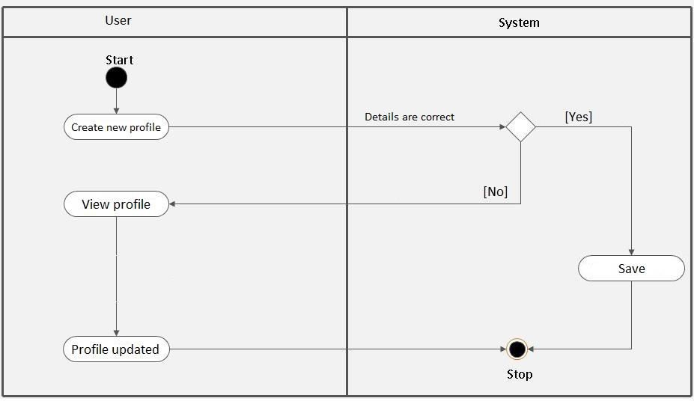

Candidate Activity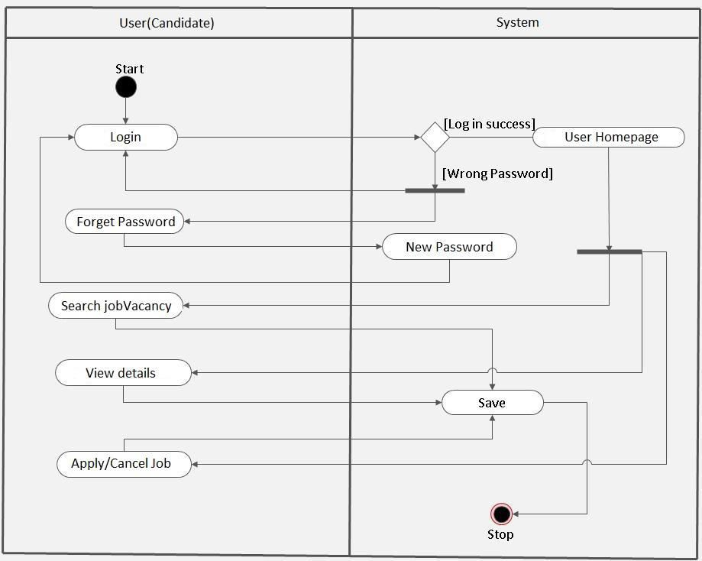

Admin Activity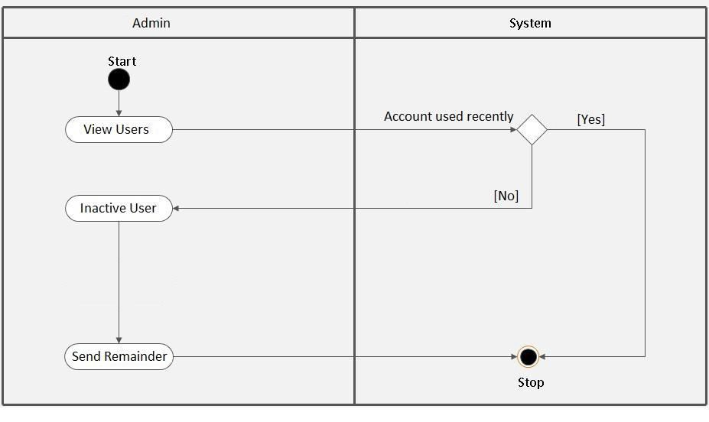

Admin User review activity

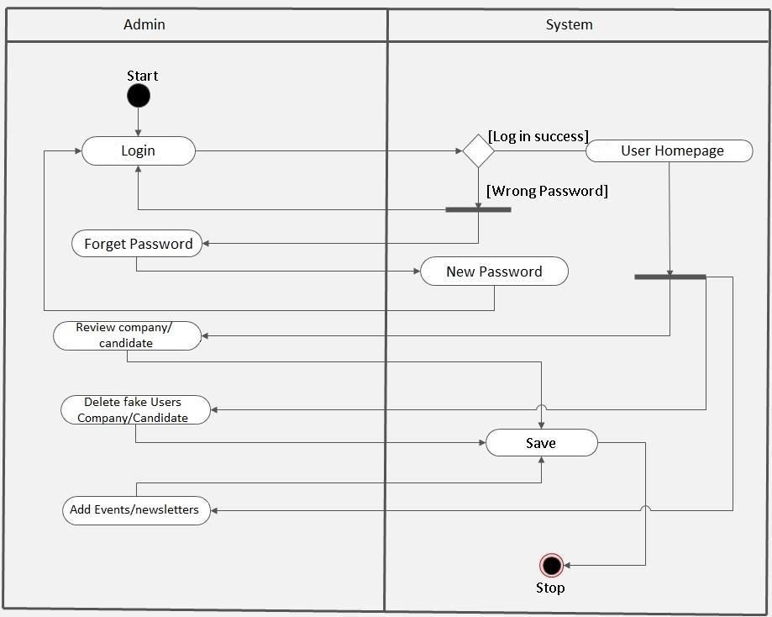

Company Activity

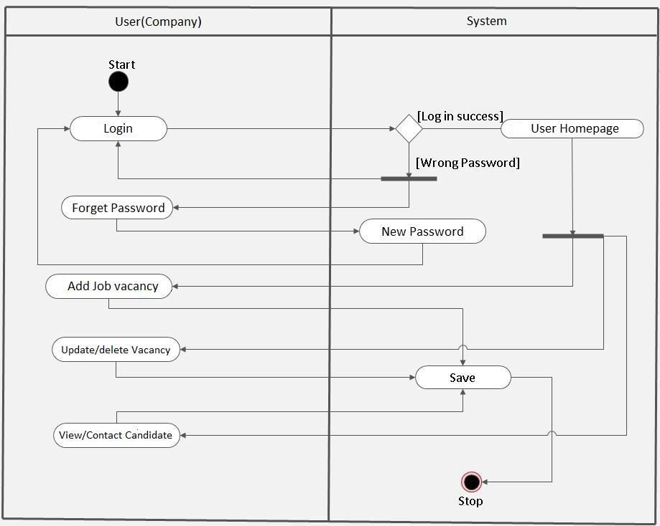

**2.5. Class Diagram:**

A class diagram represents a set of classes, interfaces, and their relationships. Class diagram can be represented as a class in a rectangular box with 3 compartments.

1. The first compartment shows the **Class Name**.
2. The second compartment shows the **attributes** of the class.
3. The third compartment shows the **methods** of the class.

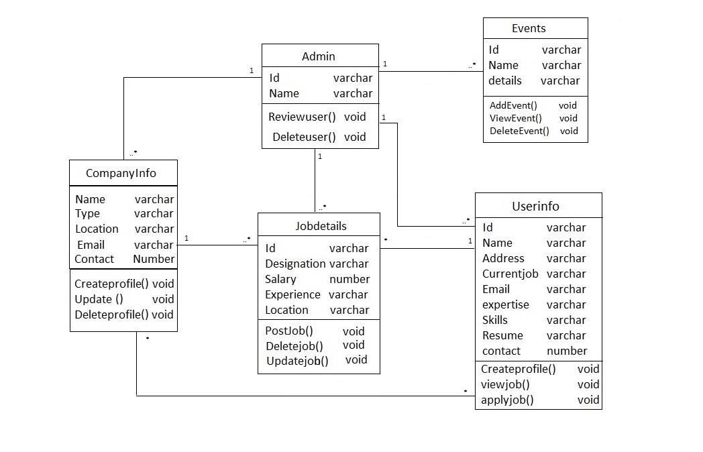

**2.6. System Sequence Diagram:**

System Sequence diagram represents communication between objects in the form of messages.

Registration System Sequence

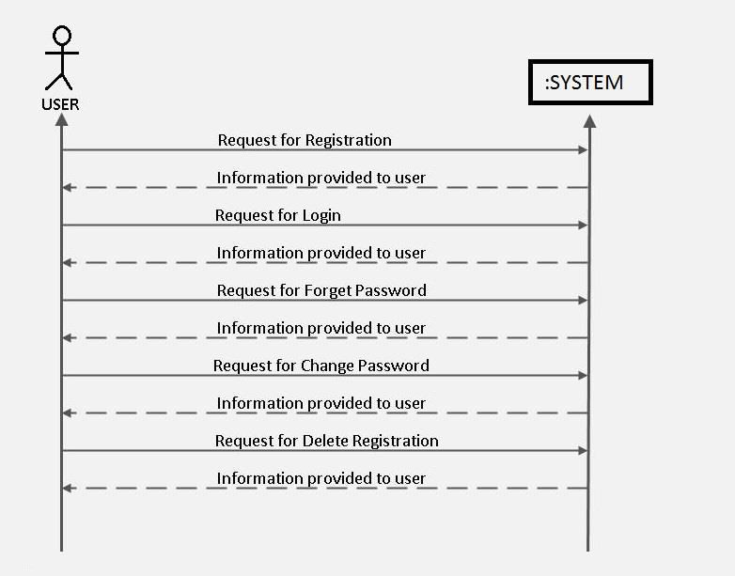

Admin System Activity

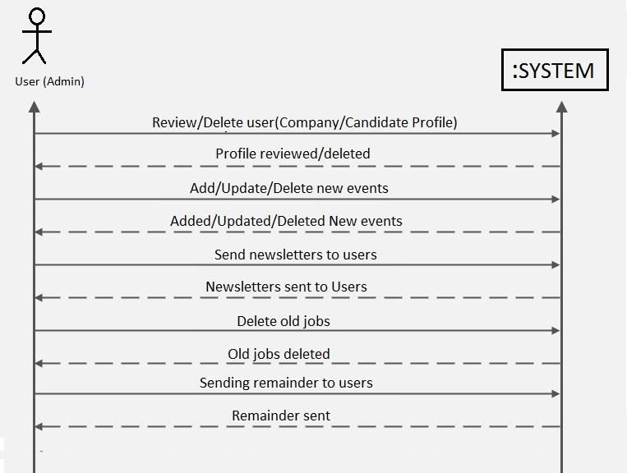

Candidate System Sequence

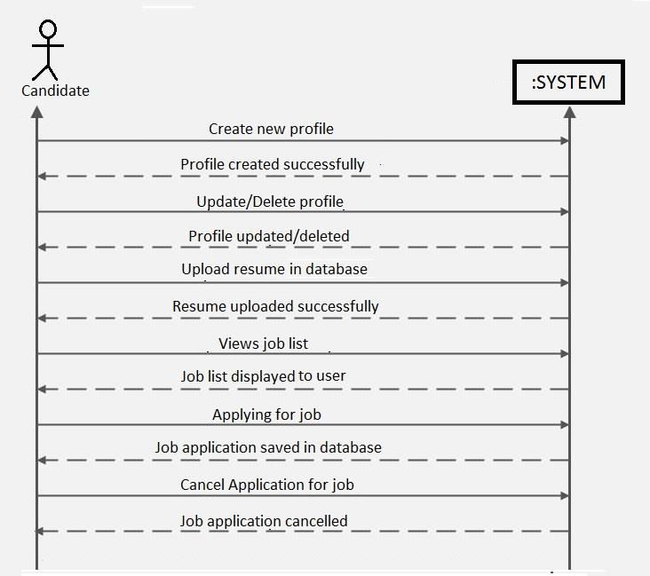

Company System Sequence

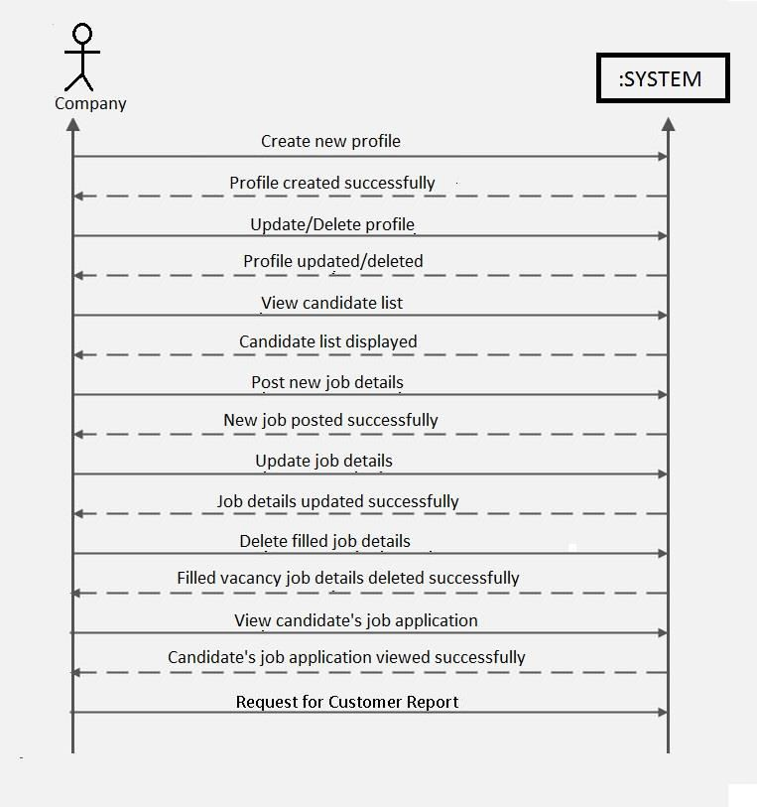

**2.7. Sequence Diagram:**

Sequence diagram represents an interaction between objects in the form of messages ordered in a sequence by time.

The difference between sequence diagram and system sequence diagram is that system sequence diagrams emphasize on the structural organization of objects as opposed to sequence diagrams that shows the messages exchanged between objects ordered in a sequence by time.

**Admin Sequence diagram**

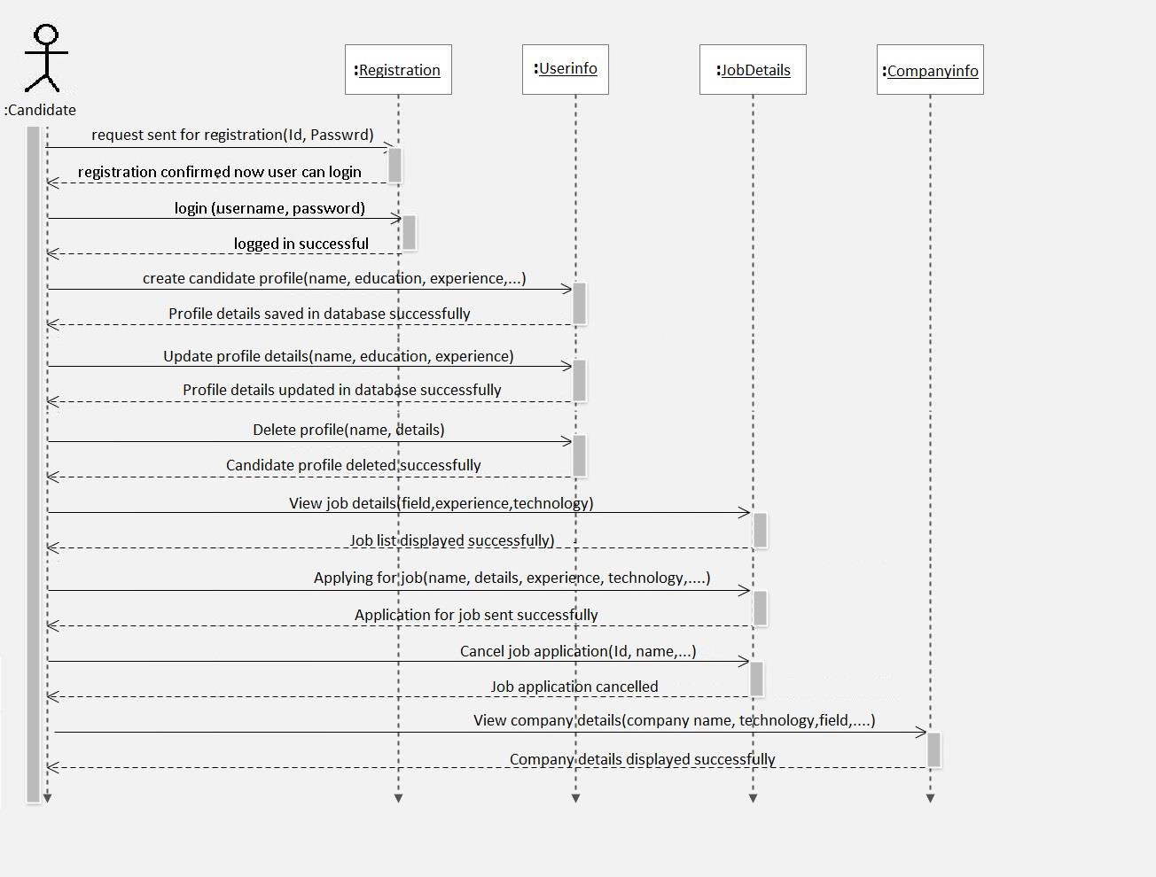**Jobseeker Sequence Diagram**

**Companies Sequence diagram**

**Chapter 3: System Design**

**3.1. Converting ERD to Class:**

3.2. Data Dictionary:

Admin Table:



Registration Table:



Jobseeker Info table



Companies Info table



Profile Image, C.V and Company URL table



Job Posting by company table



Job Application table



Feedback table



**3.3. Package Diagram:**

All the interrelated classes and interfaces of the system when grouped together form a package.

To represent these interrelated classes and interfaces UML provides package diagram.

Package diagram helps in representing the various packages of a software system and the dependencies between them.

Package diagram also gives a high-level impression of use case, class diagram and database.



**3.4. Deployment Diagram:**

A deployment diagram shows the physical placement of components in nodes over a network.

A deployment diagram can be drawn by identifying nodes and components.

**3.5. Menu Tree:**

* Default.aspx
  + CreateAccount.aspx
    - ProfessionalDetail.aspx
      * ImageCVupload.aspx
    - CompanyInfo.aspx
      * LogoURL.aspx
  + ForgetPassword.aspx
  + Login.aspx
    - WelcomeAdmin.aspx
      * DeleteUser.aspx
      * UpdateProfile.aspx
      * changepassword.aspx
      * Readfeedback.aspx
      * ReplyFeedback.aspx
    - WelcomeCompany.aspx
      * UpdateProfile.aspx
      * changepassword.aspx
      * UpdateLogoUrl.aspx
      * SendFeedback.aspx
      * PostJob.aspx
      * CheckCandidate.aspx
    - WelcomeJobSeeker.aspx
      * SerachJob.aspx
      * UpdateProfile.aspx
      * changepassword.aspx
      * UpdateImgCV.aspx
      * SendFeedback.aspx
      * ReadJobDetails.aspx
      * ApplyForJob.aspx

**Chapter 4. Implementation**

**4.1 Software Testing:**

**System Testing:**

Black box testing method was used for system testing.

The black box testing usually demonstrates that software functions are operational; that the input is properly accepted and the output is correctly produced; and that integrity of external information (databases) is maintained.

**Why testing is done**

Testing is the process of running a system with the intention of finding errors.

Testing enhances the integrity of a system by detecting deviations in design and errors in the system.

Testing aims at detecting error-prone areas. This helps in the prevention of errors in a system.

Testing also add value to the product by confirming to the user requirements.

**Causes of Errors**

The most common causes of errors in a software system are:

**Communication gap between the developer and the business decision maker:**

A communication gap between the developer and the business decision maker is normally due to subtle differences between them.

The differences can be classified into five broad areas: Thought process, Background and Experience, Interest, Priorities, Language.

**Time provided to a developer to complete the project:**

A common source of errors in projects comes from time constraints in delivering a product.

To keep to the schedule, features can be cut. To keep the features, the schedule can be slipped. Failing to adjust the feature set or schedule when problems are discovered can lead to rushed work and flawed systems.

**Over Commitment by the developer:**

High enthusiasm can lead to over commitment by the developer.

In these situations, developers are usually unable to adhere to deadlines or quality due to lack of resources or required skills on the team.

**Insufficient testing and quality control:**

Insufficient testing is also a major source of breakdown of e-commerce systems during operations, as testing must be done during all phases of development.

**Inadequate requirements gathering:**

A short time to market results in developers starting work on the Website development without truly understanding the business and technical requirements

Also, developers may create client-side scripts using language that may not work on some client browsers.

**Keeping pace with the fast changing Technology:**

New technologies are constantly introduced.

There may not be adequate time to develop expertise in the new technologies.

This is a problem for two reasons:

* First, the technology may not be properly implemented.
* Second, the technology may not integrate well with the existing environment.

**Testing Principles**

* To discover as yet undiscovered errors.
* All tests should be traceable to customer’s requirement.
* Tests should be planned long before the testing actually begins.
* Testing should begin “in the small” & progress towards “testing in the large”.
* Exhaustive Testing is not possible.
* To be most effective training should be conducted by an Independent Third Party

**Testing Objectives**

* Testing is a process of executing a program with the intent of finding errors.
* A good test case is one that has a high probability of finding an as yet undiscovered error.
* A successful test is one that uncovers an as yet undiscovered error.

**Kinds of Testing:**

**Black Box Testing- Not** based on any knowledge of internal designs or code.

Tests are based on requirements and functionality.

**White Box Testing-** Based on the knowledge of the internal logic of an application’s code. Tests are based on coverage of code statements, branches, paths and statements.

**Unit Testing-** The most ‘micro’ scale of testing; to test particular functions and code modules.

Typically done by the programmer and not by the testers, as it requires detailed knowledge of the internal program design and code

Not always easily done unless the application has a well-designed architecture with tight code; may require developing test driver modules or test harnesses.

**Integration Testing-** Testing of combined parts of an application to determine if they function together correctly.

The ‘parts’ can be code modules, individual applications, client and server applications on a network, etc.

This type of testing is especially relevant to client/ server and distributed systems.

**Functional Testing-** Black-box type testing geared to functional requirements of an application; testers should do this type of testing.

This doesn’t mean that the programmers shouldn’t check that their code works before releasing it.

**Regression Testing-** Re-testing after fixes or modifications of the software or its environment.

It is difficult to determine how much re testing is needed, especially near the end of the development cycle.

Automated testing tools can be especially useful for this type of testing.

**Acceptance Testing-** Final testing based on the specifications of the end user or customer or based on use by end-users/ customers over some limited period of time.

**User Acceptance Testing-** Determining if software is satisfactory to an end user customer.

**Tests Conducted on the System**

|  |  |
| --- | --- |
| **Testing Phase** | **Objectives** |
| Unit  Testing | The various functions within each program and the program blocks are tested for proper working. |
| Module Testing | A module is composed of various programs related to that module. |
| Integration Testing | Integration testing is done to test the functionality and interfacing between the modules. |
| Acceptance Testing | Acceptance testing is done after implementation to check if the system runs successfully in the customer environment/site. |

**4.2. Validations:**

*We had used various types of validations for our application that are listed below as:*

1. Numeric fields are validated, so that they will not accept the characters.

* Registration Form.
* Add Job details Form.
* User Profile Form.

.

2. Numeric field, where Numbers like Mobile no are to be entered are validated with only 10 digits.

* Registration Form
* User Profile Form

3. Text fields are validated so that they can only accept characters.

They will not accept any numeric data or any special characters.

1. Validation Controls such as:
   * Required field validator
   * Regular expressions.
   * Compare field validator.
   * Java Script validation for not allowing characters in numeric fields.

**4.3. Test Cases/Test Data:**



**Chapter 5. Results**

**5.1. Screen Layouts:**

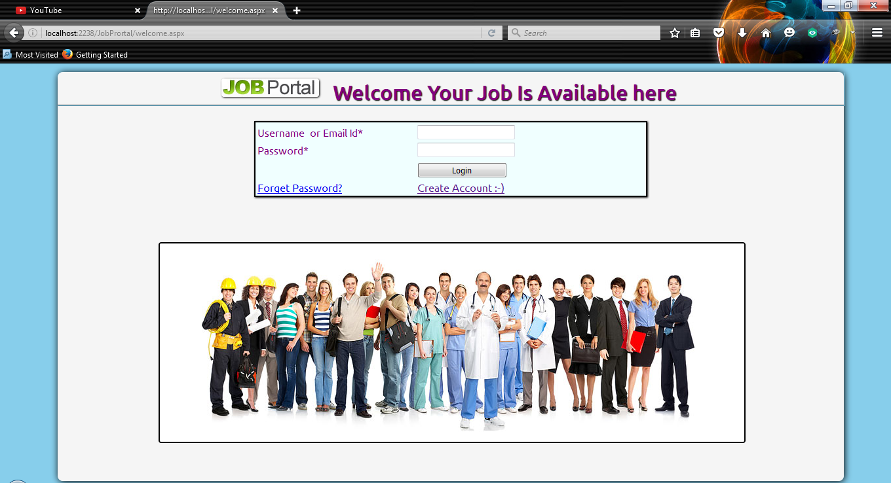**Login Screen:**

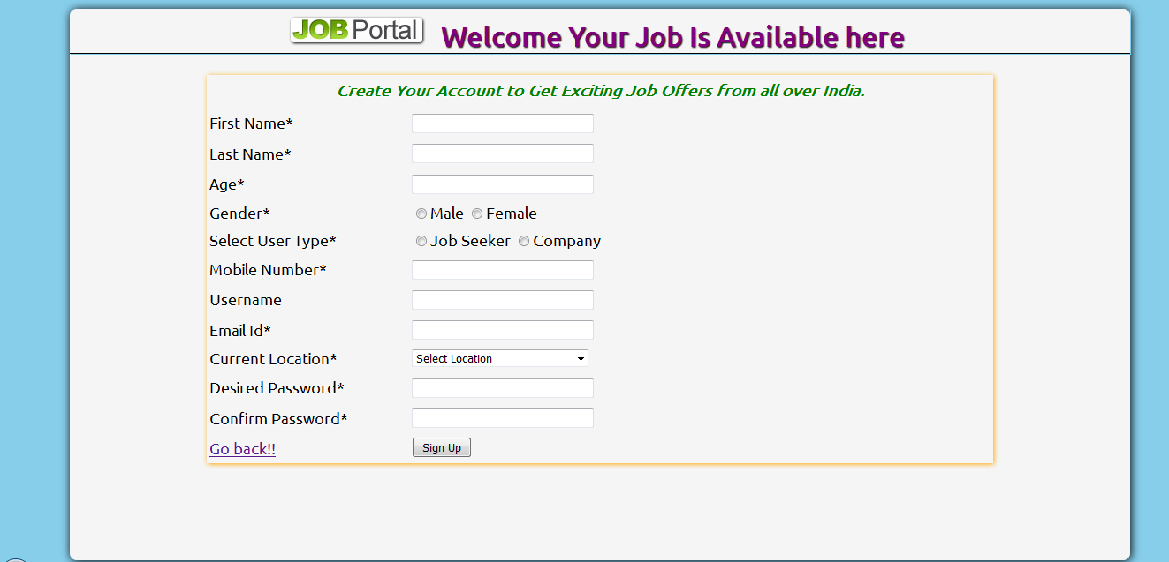**User Details:**

**Organization Details:**

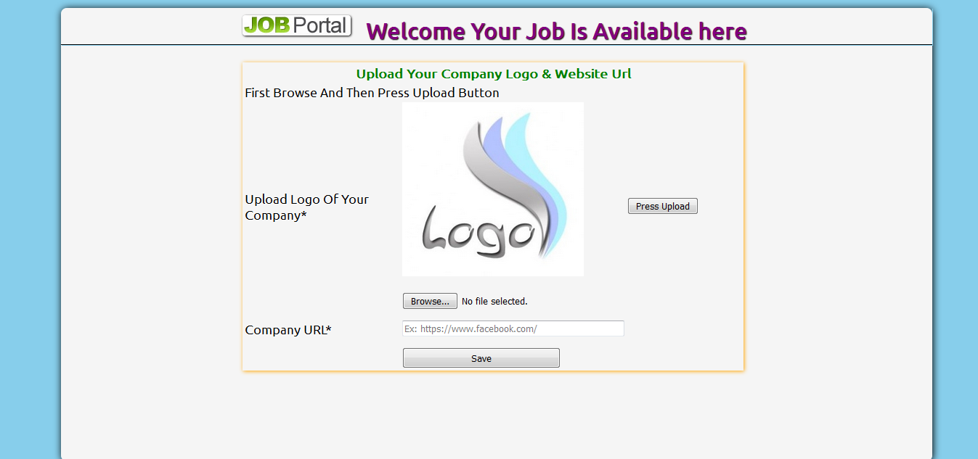

**Job Seeker Details:**

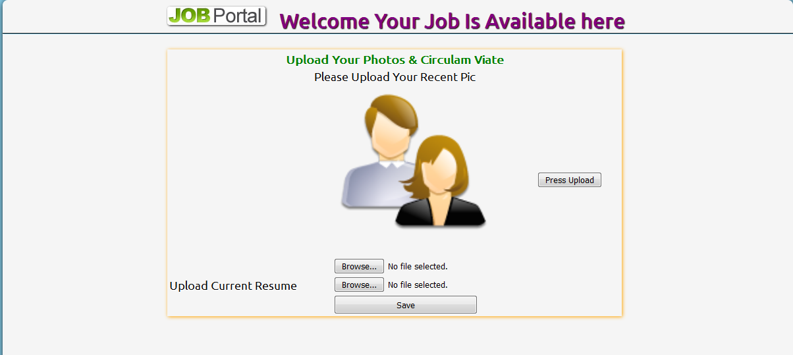

**User Home Page:**

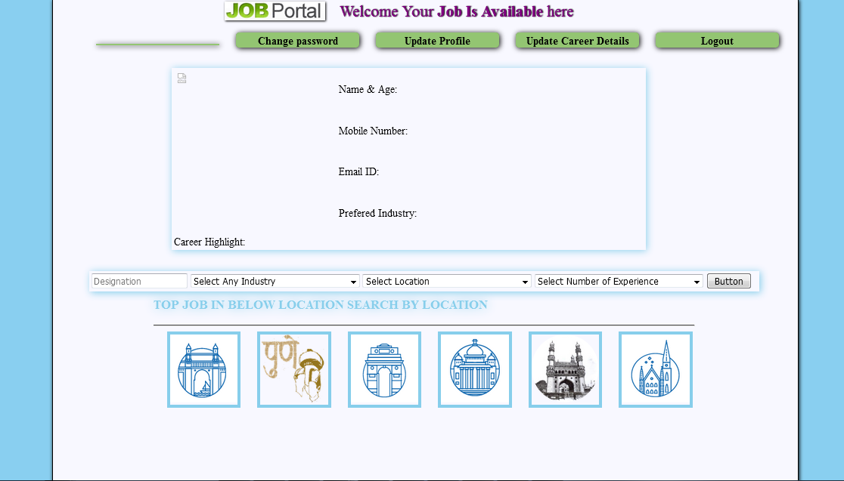

**Chapter 6: Limitations and Future Application of the Project.**

**6.1. Future Enhancement**

**Future enhancement will include following features:**

1. To ensure portability and compatibility of system.
2. Web enabled distributed system.
3. We will integrate our web-application with net banking.
4. We will integrate the US H1 visa jobs in same application with upcoming upgraded version.
5. We will include condition of candidate in our application through LinkedIn profile.
6. Company reviews by trend will also be included
7. With MySQL different database handling software such as SQL SERVER can also be integrated with the website.
8. Even in future we can develop this website in Cloud or any other upcoming new technologies by any web based languages.
9. The system can be integrated along with QR code reader technology.
10. In future we will look forward for these changes. These enhancements will definitely help in developing an efficient system.

**6.2. Implementation & Maintenance**

**Implementation**

Implementation uses the design document to produce code. Demonstration that the program satisfies its specifications validates the code. Typically, sample runs of the program demonstrating the behavior for expected data values and boundary values are required. Small programs are written using the model: -

Write/Compile/ Test

. As programs get more complicated, testing and debugging alone may not be enough to produce reliable code. Instead, we have to write programs in a manner that will help insure that errors are caught or avoided.

**Top-Down Implementation**

Top down implementation begins with the user-invoked module and works toward the modules that do not call any other modules. The implementation may precede depth-first or breadth-first.

**Bottom-Up Implementation**

Implementation begins with modules that do not call any other modules and works toward the main program. Test harness (see below) is used to test individual modules. The main module constitutes the final test harness.

**Stub Programming**

Stub programming is the implementation analogue of top-down and stepwise refinement.

It supports incremental program development by allowing for error and improvement.

A stub program is a stripped-down, skeleton version of a final program.

It doesn't implement details of the algorithm or fulfill all the job requirements. However, it does contain rough versions of all subprograms and their parameter lists.

Extensive use of procedures and parameter are the difference between stub programs and prototypes. Quick and dirty prototypes should be improved--they should be rewritten.

A stub program helps demonstrates that a program's structure is plausible.

Its procedures and functions are unsophisticated versions of their final forms, but they allow limited use of the entire program.

In particular, it may work for a limited data set. Often the high-level procedures are ready to call lower-level code, even if the more detailed subprograms haven't even been written. Such sections of code are commented out.

The comment brackets can be moved, call-by-call, as the underlying procedures are actually written.

**Incremental Program Development**

As program become more complex, changes have a tendency to introduce unexpected effects.Incremental programming tries to isolate the effects of changes. We add new features in preference to adding new functions, and add new function rather than writing new programs. The program implementation model becomes:

------ Define types/compile/fix;

------ Add load and dump functions/compile/test;

------ Add first processing function/compile/test/fix;

------ Add features/compile/test/fix;

------ Add second processing function/compile/test/fix;

------ Keep adding features/and compiling/and testing/ and fixing.

**Maintenance:**

Once the software is delivered and deployed, then maintenance phase starts. Software requires maintenance because there are some residual errors remaining in the system that must be removed as they discovered.

Maintenance involves understanding the existing software (code and related documents), understanding the effect of change, making the changes, testing the new changes, and retesting the old parts that were not changed.

The complexity of the maintenance task makes maintenance the most costly activity in the life of software product.

It is believed that almost all software that is developed has residual errors, or bugs, in them.

These errors need to be removed when discovered that leads to the software change.

This is called Corrective Maintenance. Corrective maintenance means repairing, processing or performance failures or making alterations because of previously ill-defined problems.

Software undergoes change frequently even without bugs because the software must be upgraded and enhanced to include more features and provide more services.

This also requires modification of the software. The changed software changes the environment, which in turn requires further change.

This phenomenon is called the “law of software evaluation”. Maintenance due to this phenomenon is called adaptive maintenance.

Adaptive maintenance means changing the program function. Perfect maintenance means enhancing the performance or modifying the programs according to the user’s additional or changing needs.

The keys to reduce the need for maintenance are:

* More accurately defining the user’s requirement during system development.
* Preparation of system documentation in a better way.
* Using more effective ways for designing processing logic and communicating it to project team members.
* Making better use of existing tools and techniques.
* Managing the system engineering process effectively.

**Conclusion:**

We have developed the job-portal. This portal can handle data of Recruits (Several Companies) who are looking for suitable candidates for their vacancies.

This portal will be most useful for Consultants for searching of matching job with jobseekers etc.The classic Functionality of this Application focuses on data storage. However, the means to retrieve and analyze data, to extract, transform and load data, and to manage the data dictionary.

An administrator is provided through which can enter Recruiter’s record /type of jobs/jobseeker’s description. A registration form is provided through which user can enter details of company like location of company/type of job/status of job/Qualification of jobseekers. This data once entered can be edited/deleted as required when there will be vast entries of data user can scroll the data.

This project is aimed at developing a web-based and central **ONLINE JOB PORTAL** for the HR Group for a company. Some features of this system will be creating vacancies, storing Applicants data, Interview process initiation, Scheduling Interviews, Storing Interview results for the applicant and finally Hiring of the applicant. Reports may be required to be generated for the use of HR group. This system automates the manual recruitment process. We believe that once the organization chooses to use this system, it will eventually recognize the value and necessity of this system and understand the problems involved in the manual process.

This document provides details about the entire software requirements specification for the online job portal. The project Online Job portal is aimed at developing a web-based and central Recruitment Process System for the HR Group of a company.

**Bibliography:**

The following books were used extensively for the project development and implementation.

1. Object-Oriented Analysis and Design Using UML.
2. MySQL DBA by- John Sanson
3. ASP .NET with C# by Sangeela Sagar and Pallavi Tawde.
4. ASP .NET The Complete Reference 1st Edition- by Matthew Macdonald.
5. Object Modeling language by Martin Fowler.
6. MySQL open source 2008 by Paul Nielson
7. www. msdn.microsoft.com
8. www.w3schools.com
9. www.codeproject.com
10. www.aspdotnetfunda.com
11. www.asp.net.com
12. Introduction to Object-Oriented Analysis and Design and Unified Process by Craig Larman.
13. ASP .NET by Vikas Gupta